General Technical Terminology

What is General Technical Terminology
# Source: Chatgpt (GPT-4-turbo) at [7/31/2025]
General Technical Terminology includes technical or semi-technical terms that are not limited to a single field but are used across multiple disciplines. These terms often retain a consistent meaning in various contexts and are commonly understood by educated users or professionals in many areas.

✅ Key Features:
# Source: Chatgpt (GPT-4-turbo) at [7/31/2025]
- Cross-disciplinary usage – shared across fields like science, engineering, computing, and business.
- More accessible than highly specialized terminology.
- Frequently found in reports, research papers, technical manuals, and interdisciplinary communication.
- Typically standardized, though context may slightly shift usage.

📚 Examples:
# Source: Chatgpt (GPT-4-turbo) at [7/31/2025]
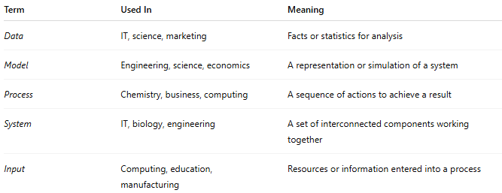

Term | Used In | Meaning
Data | IT, science, marketing | Facts or statistics for analysis
Model | Engineering, science, economics | A representation or simulation of a system
Process | Chemistry, business, computing | A sequence of actions to achieve a result
System | IT, biology, engineering | A set of interconnected components working together
Input | Computing, education, manufacturing | Resources or information entered into a process

👥 Users:
# Source: Chatgpt (GPT-4-turbo) at [7/31/2025]
- Multidisciplinary researchers
- Technical writers
- Educators and trainers
- Industry professionals across various domains

